Adventure Pathway
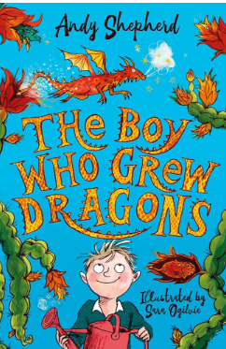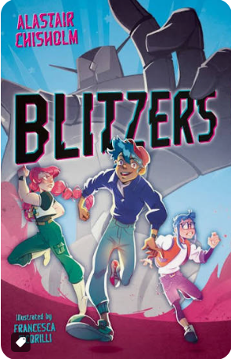
Learners will explore the age-respectful class novels Blitzers and the Boy Who Grew Dragons, using the stories as engaging context for developing their literacy skills. They will explore what makes a sentence, including capital letters and full stops, nouns and proper nouns, adjectives, verbs and conjunctions, as well as sequencing events, writing instructions and developing skills in planning, rereading and editing their work.

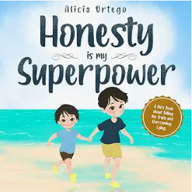
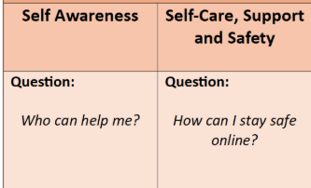
English
Love of Reading
Learning For Life
Learners will develop their understanding of place value through fun, practical activities and games. They will use a range of hands-on manipulatives to explore how numbers are made up of thousands, hundreds, tens and ones, while also applying their learning in everyday situations and across other lessons. This practical approach will help learners to build confidence and understand how place value is used in real life.

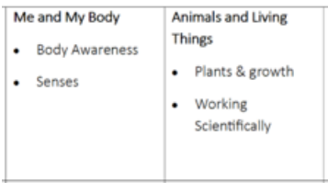
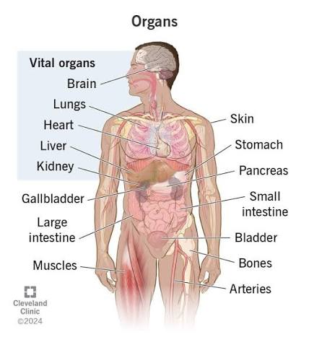
Maths
Science
Learners will develop their game sense through invasion games, learning to move, pass, communicate and work as part of a team. They will also explore gymnastics,

Learners will explore the technology around us, identifying different types of technology they see and use in everyday life. They will consider what technology is used for and how it helps us at home, at school and in the wider community, through practical and engaging activities.

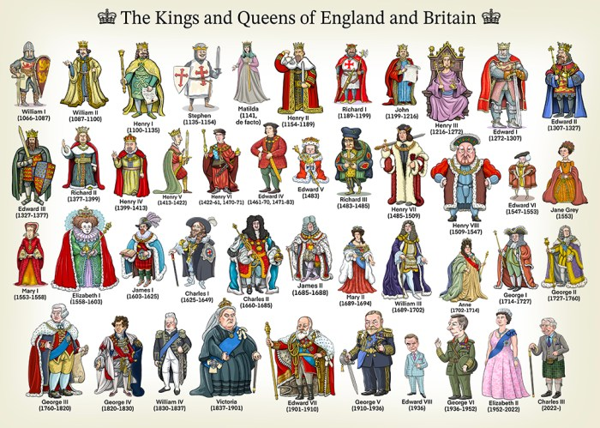
History: British Kings and Queens
PRE: What is Religion and what do people believe?

PE
World Studies
This term learners will have the opportunity to learn…

Behaviour Curriculum
The MBA Behaviour Curriculum supports our learners by developing emotional literacy, wellbeing, relationships, values and community understanding. Through structured opportunities to explore feelings, practice self-regulation, build social skills, reflect on beliefs and access the wider community, we help pupils grow in confidence, resilience and responsibility.
My Feelings
Learners could explore different feelings through films, stories, role play and practical activities, helping them to recognise, name and communicate their emotions.
My Wellbeing
Learners could take part in wellbeing walks, yoga, mindfulness, sensory activities and relaxation exercises to explore ways of looking after their physical and emotional wellbeing.
My Relationships
Learners could develop their social skills through board games, computer games, team sports, turn-taking activities and opportunities to work and communicate with others.
My Beliefs and Values
Learners could discuss and explore real-life situations, current events and age-appropriate news stories, considering different viewpoints and developing their understanding of beliefs, values and respectful behaviour.
Accessing My Community
Learners could develop their independence and confidence through regular opportunities to access the local community, such as visiting shops, parks, cafés, libraries and other community facilities, using the minibus where appropriate.

Music: Big Question: How can we use our listening, choosing and turn-taking skills to become confident musicians?
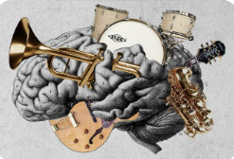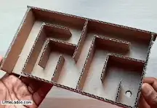
DT: Learners will explore resistant materials through practical, hands-on projects, developing their skills in designing, making and safely using a range of materials.

Learners will explore “What can you have on toast?”, planning and preparing a range of different foods to accompany toast while developing their practical cooking skills, confidence and understanding of safe food preparation.

Creativity
Digital Literacy
Food Technology

Autumn Term 2026
Key Stage 3

Key Stage 3
Autumn Term
Key Stage 3
Project Name

